**Object Oriented Programming**

**Lab report: 5**



|  |  |
| --- | --- |
| Name | Ali Salman |
| Reg no | FA22-BCE-005 |
| Class | BCE- 4 |
| Instructor’s Name | Prof. Tayyab Rasul |

**Lab 05 – *Constructor and Function Overloading***

**Lab Tasks**

**5.1.**

Area of a circle is **π** × r2 where r = radius

Area of a triangle is ½ × b × h where b = base, h = height

Area of a rectangle is w × h w = width, h = height

Area of a square is a2 where a = length of side

Write four different functions with same name that is Area to calculate the area of circle, triangle, rectangle and square.

Program:

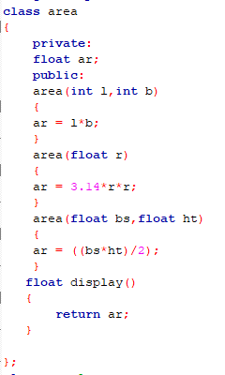

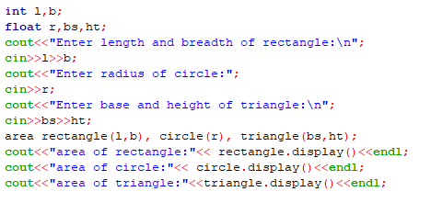

Output:

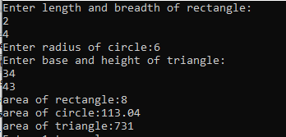

**5.2.** Write a definition of a Counter class having one private data member count of integer type. This class has following functions

• void inc_count( ); // will increment the value of count by 1

• int get_count ( ); // will return the value of count this class has two constructor

• Counter( ); // that initialize count by 0

• Counter (int i); // that initialize the count by i

Create two objects of Counter class. Write a cout statement in constructor and then check whether that statement appear when two object are created. Then increment object 1 3 times and increment object 2 4 times and display their count values.

Program:

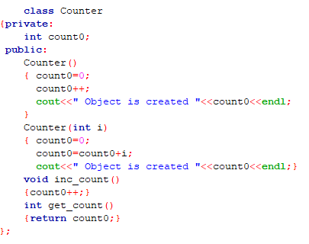

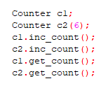

Output:



**5.3** Write a definition of class named Race. It has following private data member

• carNo (int)

• driverID (int)

• carModel (int)

The class has one constructor Race (int, int, int) that initializes the values of carNo, driverID and carModel. Race class has following member functions

• void InputValues( ) // this will be used to input values of data member of Book object from user

• void setValues(int cn, int di, int cm); // it will assign values of cn, di and cm to carNo, driverID and carModel respectively

• void display( ); // it displays the value of private

Create two object of Rave class. Assign values using InputValues and setValues function and display them using display function.

Program:

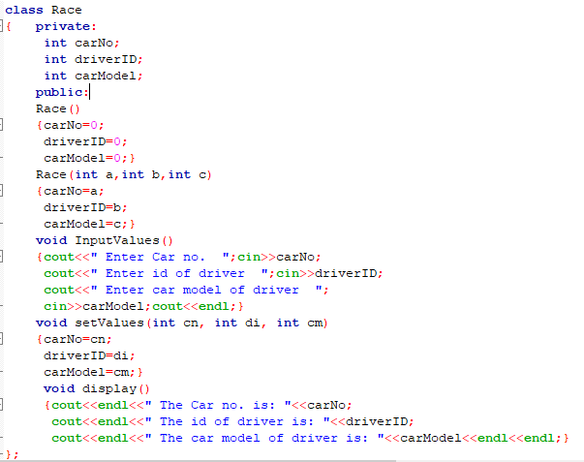

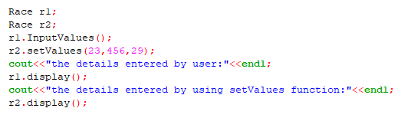

Output:

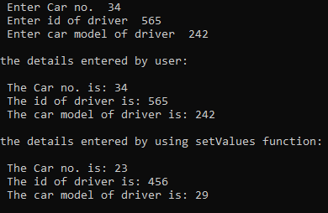

**5.4** Write a definition of a distance class as shown in the example 4.2 above. Make all the appropriate function constant. Include a constant data member called id of integer type.

Create two object constant and non-constants. Assign values and display them. Also check what happens

• If you try to modify private data member of an object from the definition of const function

• If you try to modify the private data member of const object from the definition of non-constant function.

Program:

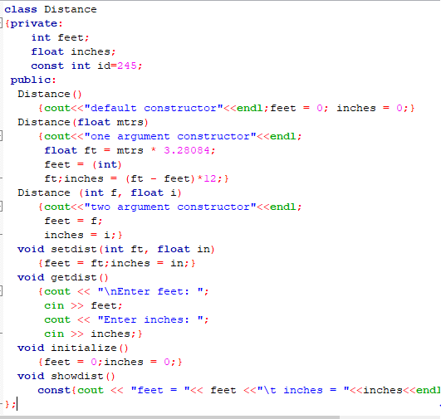

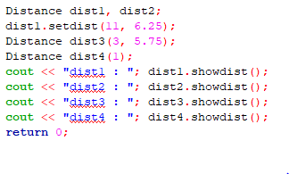

Output:

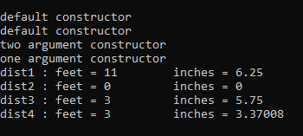

**Home Tasks**

Write a definition of class named Date that contains three elements the month, the day of the month, and the year, all of type int.

• Write two constructors, a default constructor (that initialize each data element of object with zero) and a constructor that takes three parameters (the month, the day of the month, and the year) and initialize the data member of the object with these parameters.

• Write a function void printDate() that displays the data elements of the object.

• Write a function void setDate(int, int, int) that takes three parameters (he month, the day of the month, and the year) and initialize the data member of the object with these parameters.

Write a main function create two object of class **Date**, the data member of one object is initialized with zero through default constructor. The data member of second object is initialized with some values using a constructor that takes three parameters.

Prompt the user to input date (the month, the day of the month, and the year) in a main function, assign these values to the first object (using function setDate) and then display the value of the data members of two objects using function printDate().

Program:

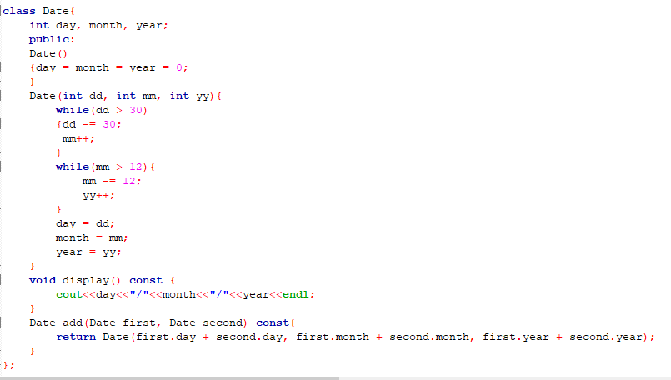

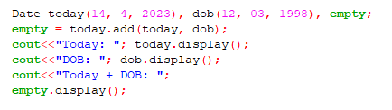

Output:

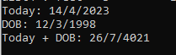

Critical analysis:

In this lab, we learn the meaning and purpose of constructors, how they aid in object initialization, the many types of constructors, method overloading, and the const keyword. If an object's private data members can be initialized automatically when it is created, avoiding the need for a separate call to a member function, it will be a practical solution. After completing this lab, we understand what a constructor is, when and how to use it, and when method overloading is appropriate. Additionally, the student will be familiar with constant functions, constant members, and constant objects.